Why Some Civil War Soldiers Glowed in the Dark Matt Soniak
filed
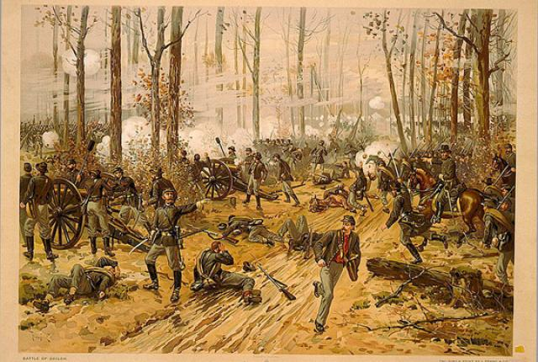
By the spring of 1862, a year into the American Civil War, Major General Ulysses S. Grant had pushed deep into Confederate territory along the Tennessee River. In early April, he was camped at Pittsburg Landing, near Shiloh, Tennessee, waiting for Maj. Gen. Don Carlos Buell’s army to meet up with him.
On the morning of April 6, Confederate troops based out of nearby Corinth, Mississippi, launched a surprise offensive against Grant’s troops, hoping to defeat them before the second army arrived. Grant’s men, augmented by the first arrivals from the Ohio, managed to hold some ground, though, and establish a battle line anchored with artillery. Fighting continued until after dark, and by the next morning, the full force of the Ohio had arrived and the Union outnumbered the Confederates by more than 10,000.
The Union troops began forcing the Confederates back, and while a counterattack stopped their advance it did not break their line. Eventually, the Southern commanders realized they could not win and fell back to Corinth until another offensive in August (for a more detailed explanation of the battle, see this animated history).
All told, the fighting at the Battle of Shiloh left more than 16,000 soldiers wounded and more 3,000 dead, and neither federal or Confederate medics were prepared for the carnage.
The bullet and bayonet wounds were bad enough on their own, but soldiers of the era were also prone to infections. Wounds contaminated by shrapnel or dirt became warm, moist refuges for bacteria, which could feast on a buffet of damaged tissue. After months marching and eating field rations on the battlefront, many soldiers’ immune systems were weakened and couldn’t fight off infection on their own. Even the army doctors couldn’t do much; microorganisms weren’t well understood and the germ theory of disease and antibiotics were still a few years away. Many soldiers died from infections that modern medicine would be able to nip in the bud.

A Bright Spot
Some of the Shiloh soldiers sat in the mud for two rainy days and nights waiting for the medics to get around to them. As dusk fell the first night, some of them noticed something very strange: their wounds were glowing, casting a faint light into the darkness of the battlefield. Even stranger, when the troops were eventually moved to field hospitals, those whose wounds glowed had a better survival rate and had their wounds heal more quickly and cleanly than their unilluminated brothers-in-arms. The seemingly protective effect of the mysterious light earned it the nickname “Angel’s Glow.”
In 2001, almost one hundred and forty years after the battle, seventeen-year-old Bill Martin was visiting the Shiloh battlefield with his family. When he heard about the glowing wounds, he asked his mom - a microbiologist at the USDA Agricultural Research Service who had studied luminescent bacteria that lived in soil - about it.
“So you know, he comes home and, 'Mom, you're working with a glowing bacteria. Could that have caused the glowing wounds?’” Martin told Science Netlinks. “And so, being a scientist, of course I said, ‘Well, you can do an experiment to find out.’”
And that’s just what Bill did.
He and his friend, Jon Curtis, did some research on both the bacteria and the conditions during the Battle of Shiloh. They learned that Photorhabdus luminescens, the bacteria that Bill’s mom studied and the one he thought might have something to do with the glowing wounds, live in the guts of parasitic worms called nematodes, and the two share a strange lifecycle. Nematodes hunt down insect larvae in the soil or on plant surfaces, burrow into their bodies, and take up residence in their blood vessels. There, they puke up the P. luminescens bacteria living inside them. Upon their release, the bacteria, which are bioluminescent and glow a soft blue, begin producing a number of chemicals that kill the insect host and suppress and kill all the other microorganisms already inside it. This leaves P. luminescens and their nematode partner to feed, grow and multiply without interruptions.
As the worms and the bacteria eat and eat and the insect corpse is more or less hollowed out, the nematode eats the bacteria. This isn’t a double cross, but part of the move to greener pastures. The bacteria re-colonize the nematode’s guts so they can hitch a ride as it bursts forth from the corpse in search of a new host.
The next meal shouldn’t be hard to find either, since P. luminescens already sent them an invitation to the party. Just before they got got back in their nematode taxi, P. luminescens were at critical mass in the insect corpse, and scientists think that that many glowing bacteria attract other insects to the body and make the nematode’s transition to a new host much easier.

A Good Light
Looking at historical records of the battle, Bill and Jon figured out that the weather and soil conditions were right for both P. luminescens and their nematode partners. Their lab experiments with the bacteria, however, showed that they couldn’t live at human body temperature, making the soldiers’ wounds an inhospitable environment. Then they realized what some country music fans already knew: Tennessee in the spring is green and cool. Nighttime temperatures in early April would have been low enough for the soldiers who were out there in the rain for two days to get hypothermia, lowering their body temperature and giving P. luminescens a good home.
Based on the evidence for P. luminescens’s presence at Shiloh and the reports of the strange glow, the boys concluded that the bacteria, along with the nematodes, got into the soldiers’ wounds from the soil. This not only turned their wounds into night lights, but may have saved their lives. The chemical cocktail that P. luminescens uses to clear out its competition probably helped kill off other pathogens that might have infected the soldiers’ wounds. Since neither P. luminescens nor its associated nematode species are very infectious to humans, they would have soon been cleaned out by the immune system themselves (which is not to say you should be self-medicating with bacteria; P. luminescens infections can occur, and can result in some nasty ulcers). The soldiers shouldn’t have been thanking the angels so much as the microorganisms.
As for Bill and Jon, their study earned them first place in team competition at the 2001 Intel International Science and Engineering Fair.
Read the full text here: http://mentalfloss.com/article/30380/why-some-civil-war-soldiers-glowed-dark#ixzz2MPAYfAil
--brought to you by mental_floss! - See more at: http://mentalfloss.com/article/30380/why-some-civil-war-soldiers-glowed-dark#sthash.xyrrky4I.dpuf

